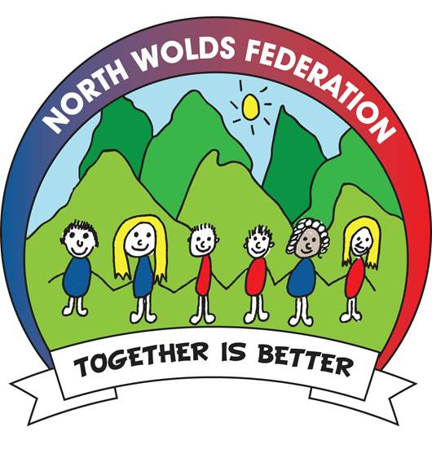
Governor Details as at 12th October 2016

Governor Names | Type of Governor |  | Term of Office
Mr. Andrew Smith | Executive  Head Teacher | Ex-Officio
Mrs. Nichola Allerston | Deputy Head  Co-opted |  | 01.07.14 – 30.06.18
Mr. Mike Eckersley | LA |  | 01.07.14 – 30.06.18
Revd Steve Johnson | Foundation | Ex-Officio | 08.09.2014
Mr. Antony Parkinson | Foundation |  | 15.07.14 – 14.07.18
Mr. Cliff Buck | Parent  MRCPS |  | 01.07.14 – 30.06.18
Mr. Simon Carey | Ex Parent  NCPS |  | 01.07.14 – 12.11.15
Mrs. Claire Roberts | Staff |  | 01.07.14 – 30.06.18
Mr. Andrew Howson | Co-opted |  | 01.07.14 – 30.06.18
Mr. Geoffrey Barnes | Co-opted |  | 12.10.15 – 11.10.19
Mr. Marcus Hyde | Co-opted |  | 12.10.15 – 11.10.19
Dr. Kirsty Miller | Co-opted |  | 01.07.14 – 30.06.18
Mr. Andrew Lyle | Co-opted |  | 01.07.14 – 30.06.18
Mr. Colin Horton | Co-opted |  | 01.07.14 – 30.06.18
Mrs. Jo Parsons | Ex Co-opted |  | 01.07.14 – 01.02.16
Mrs. Cerri Belt | Parent NCPS |  | 14.12.15 – 13.12.19
Mrs. Claire Bell | Co-Opted |  | 01.02.16 – 31.01.20
Mrs. Michelle Walker | Clerk |  | n/a

2016/17
Composition of Committees

Quality and Standards  Mr. C. Horton - Chair  Mr. C. Buck – Vice Chair  Mr. A. Smith  Mr. M. Eckersley  Mr. T. Parkinson  Mr. G. Barnes  Dr. K. Miller  Mr. A. Howson  Revd. S. Johnson  Mrs. N. Allerston | Curriculum and Community  Mr. A. Howson - Chair  Mrs. K. Miller - Vice Chair  Mr. A. Smith  Mr. T. Parkinson  Revd. S. Johnson  Mrs. C. Roberts  Mrs. C. Belt  Mr. A. Lyle  Mrs. N. Allerston  Mrs. J. Parsons (resigned 01.02.16) | Resources  Mr. M. Eckersley - Chair  Mrs. C. Bell – Vice Chair  Mr. C. Buck  Mr. T. Parkinson  Mrs. C. Belt  Mr. M. Hyde  Mr. G. Barnes  Mr. A. Smith  Mrs. J. Parsons (resigned 1.02.16)  Mr. S. Carey (Resigned 12.11.15)  Mrs. C. Fussey (Obs)
Strategy  Mr. C. Horton – Q & S  Mr. A. Howson – C & C  Mr. M . Eckersley – Res/Vice Govs  Mr. T. Parkinson – Chair Govs  Mr. A. Smith – Ex Head  Mrs. N. Allerston – Head MRCPS  Mrs. R. Schaffer – Head NCPS | Pay & Performance Management Team  Mr. T. Parkinson  Mr. M. Eckersley  Mr. C. Buck  Mr. S. Carey (Resigned 12.11.15)  Mr. C. Horton | Kitchen Committee  Mr. A. Smith  Mrs. N. Allerston  Mr. T. Parkinson  Mr. M. Eckersley  Mrs. J. Parsons (Resigned 01.02.16)

GOVERNORS ATTENDANCE 2015/16
Details | Smith | Allerston | Buck | Miller | Parkinson | Howson | Eckersley | Carey | Belt | Horton | Parsons | Lyle | Roberts | Johnson | Barnes | Hyde | Bell
Full Governors Meetings
October 2015 | ✔ | ✔ | ✔ | ✔ | ✔ | ✔ | ✔ | ✔ |  | A | ✔ | A | ✔ | A
November 2015 | ✔ | ✔ | A | ✔ | ✔ | ✔ | ✔ |  |  | ✔ | ✔ | ✔ | A | A | ✔ | ✔
February 2016 | ✔ | ✔ | A | ✔ | ✔ | ✔ | ✔ |  | ✔ | ✔ | ✔ | ✔ | ✔ | A | ✔ | ✔
May 2016 | ✔ | A | ✔ | A | ✔ | ✔ | ✔ |  | ✔ | ✔ |  | ✔ | ✔ | A | ✔ | A | ✔
July 2016 | ✔ | ✔ | ✔ | ✔ | ✔ | ✔ | ✔ |  | ✔ | A |  | ✔ | ✔ | A | ✔ | ✔ | ✔
SDP Meetings
Review – January 2016
Planning – June 2016 | ✔ | ✔ | ✔ | X | ✔ | ✔ | ✔ |  | ✔ | X |  | X | ✔ | X | X | X | A
Curriculum & Community
September 2015 | ✔ | ✔ |  | ✔ | ✔ | ✔ |  |  |  |  | ✔ | A | ✔ | ✔
November 2015 | ✔ | ✔ |  | A | ✔ | ✔ |  |  |  |  | A | A | ✔ | ✔ |  | ✔
March 2016 | A | ✔ |  | ✔ | ✔ | ✔ |  |  | ✔ |  |  | ✔ | A | ✔ |  | ✔ | ✔
June 2016 | ✔ | ✔ |  | ✔ | ✔ | A |  |  | ✔ |  |  | ✔ | A | A |  | ✔ | ✔
Resources
October 2015 | ✔ | ✔ | A |  | ✔ |  | ✔ | A |  |  | ✔
November 2015 | ✔ | ✔ | A |  | ✔ |  | ✔ |  |  |  | ✔ |  |  |  | X | ✔
January 2016 | ✔ | ✔ | ✔ |  | ✔ |  | ✔ |  | ✔ |  | ✔ |  |  |  | ✔ | ✔
March 2016 | A | ✔ | A |  | ✔ |  | ✔ |  | ✔ |  |  |  |  |  | ✔ | ✔ | ✔
April 2016 | ✔ | ✔ | ✔ |  | ✔ |  | A |  | ✔ |  |  |  |  |  | ✔ | X | ✔
May 2016 | ✔ | A | ✔ |  | ✔ |  | ✔ |  | ✔ |  |  |  |  |  | ✔ | A | A
June 2016 | ✔ | ✔ | ✔ |  | ✔ |  | ✔ |  | ✔ |  |  |  |  |  | ✔ | ✔ | ✔

 | Smith | Allerston | Buck | Miller | Parkinson | Howson | Eckersley | Carey | Belt | Horton | Parsons | Lyle | Roberts | Johnson | Barnes | Hyde | Bell
Quality and Standards
September 2015 | ✔ | ✔ | A | ✔ | ✔ | ✔ | A |  |  | ✔ |  |  |  | A
November 2015 | ✔ | ✔ | ✔ | A | ✔ | ✔ | ✔ |  |  | ✔ |  |  |  | ✔ | ✔
February 2016 | ✔ | ✔ | A | ✔ | ✔ | ✔ | ✔ |  |  | ✔ |  |  |  | A | ✔
April 2016 | ✔ | ✔ | ✔ | ✔ | ✔ | ✔ | A |  |  | ✔ |  |  |  | ✔ | ✔ |  | ✔
July 2016 | ✔ | ✔ | ✔ | ✔ | ✔ | ✔ | ✔ |  |  | A |  |  |  | ✔ | ✔ |  | X

NORTH WOLDS FEDERATION GOVERNING BODY
SCHOOL REGISTER OF BUSINESS INTERESTS AND CONFLICTS OF INTERESTS – as at 10th October 2016

NAME | ROLE | ANY INTEREST? | NAME & NATURE OF BUSINESS | NATURE OF INTEREST | DATE INTEREST STARTED
Andrew Smith | Executive Head | No
Revd. S. Johnson | Foundation Governor | Yes | Diocese of Lincoln/LAAT | Employed by the Diocese
Tony Parkinson | Foundation Governor | Yes | Clothing supplier | Supplies garments to local companies who supply school uniform
Marcus Hyde | Co-opted Governor | No
Clifford Buck | Parent Governor | No
Colin Horton | Co-opted Governor | No
Mike Eckersley | LEA Governor | No
Andrew Lyle | Co-opted Governor | Yes | Farming | Offers farm visits to local schools.
Claire Roberts | Staff Governor | No
Dr. K. Miller | Co-opted Governor | Yes | Husband – Paul Miller  Website Designer | Designing web site for the School and for the federation.
Andrew Howson | Co-opted Governor | No
Nichola Allerston | Co-opted/Head Of School | No
Geoffrey Barnes | Co-opted Governor | No
Cerri Belt | Parent NCPS | No
Claire Bell | Co-opted Governor | No

